***Section 1:***

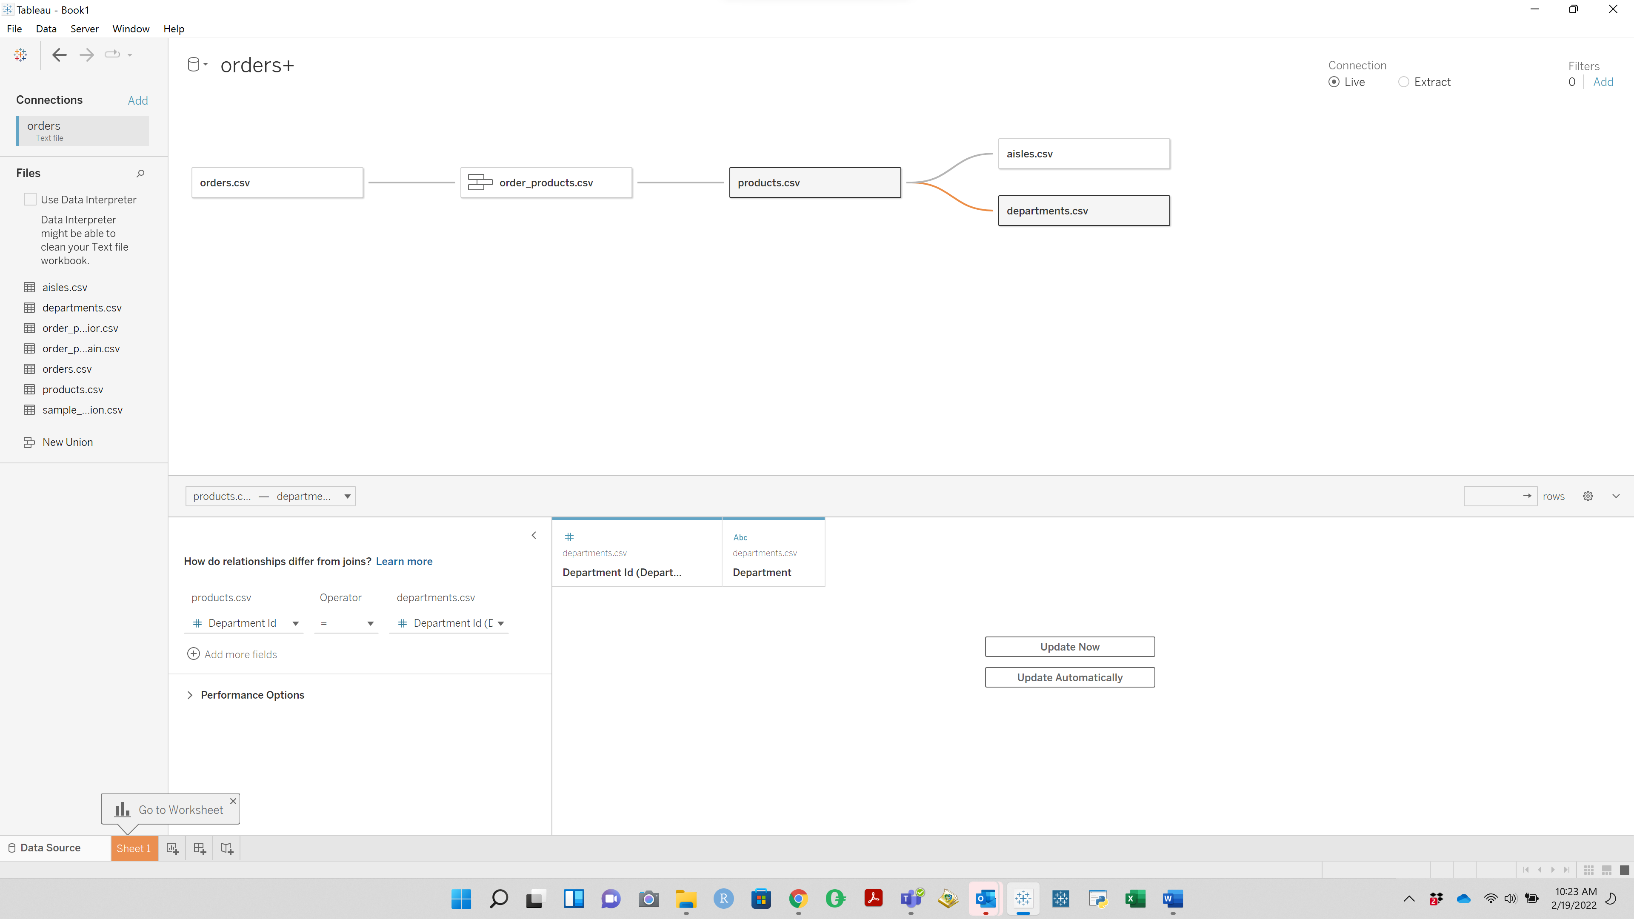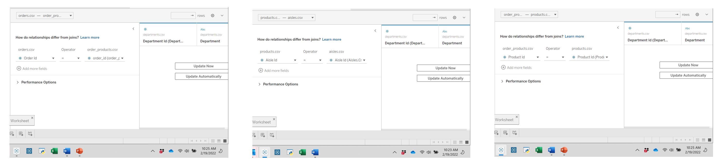

***Section 2:***

***The primary groups and individuals that are the focus of my communication:***

The Marketing Team

***The executive role or position that is the key decision maker in my audience:***

The Director of Marketing

***Audience’s Depth of Experience:***

The audience would likely have a deep understanding of the data presented as they should be familiar with our customer types and products we shop for on their behalf.

***Scope of the audience:***

The audience would have a narrow scope focused on marketing efforts to our clients.

***What my audience cares about:***

* Driving a profitable business model
* Capitalizing on opportunities to generate revenue
* Not wasting marketing dollars
* Creating and delivering marketing content that is relevant to the client

***Desired action to be taken by audience:***

I would like for the audience to approve a new marketing innitiative focused on repurchased items and segmented targets. With defined target audiences based on the time of the day and day of the week, marketing material can cater towards pushing products that have been repurchased by our overall customer base during the same periods in which our target groups shop. These marketing materials can be come in the form of email, application notifications, web ordering, application ordering, and other forms of digital communication.

***What are the stakes:?*** *(what matters, what is the point)*

By focusing our marketing materials on products that have historically proven to have a higher repurchase rate, we increase the chances of clients repurchasing more often. With increased repurchasing, we could drive down the amount of days between purchases and might simultaneously increase items per transaction. If successful, we would generate higher value sales and generate sales more often, generating more revenue for Instacart.

***The big idea****:* Let’s target segmented clients by marketing products that are proven to drive recurring business!!!

***Section 3:***

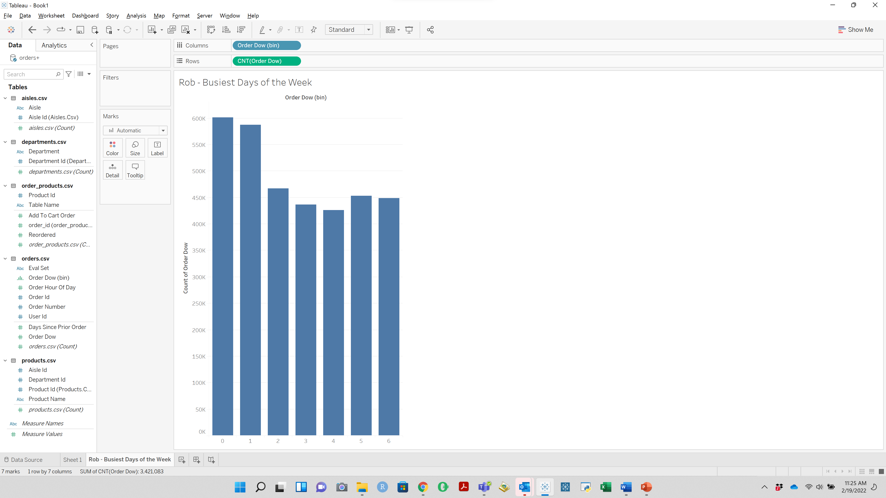

**QUESTION 1**: The two busiest days of the week are days 0 & 1

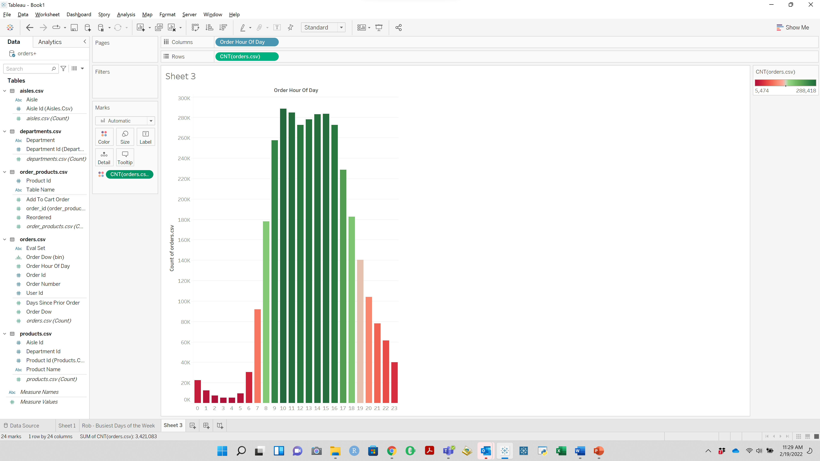

**QUESTION 2**: The 11 busiest hours fall between 8:00 and 18:00.

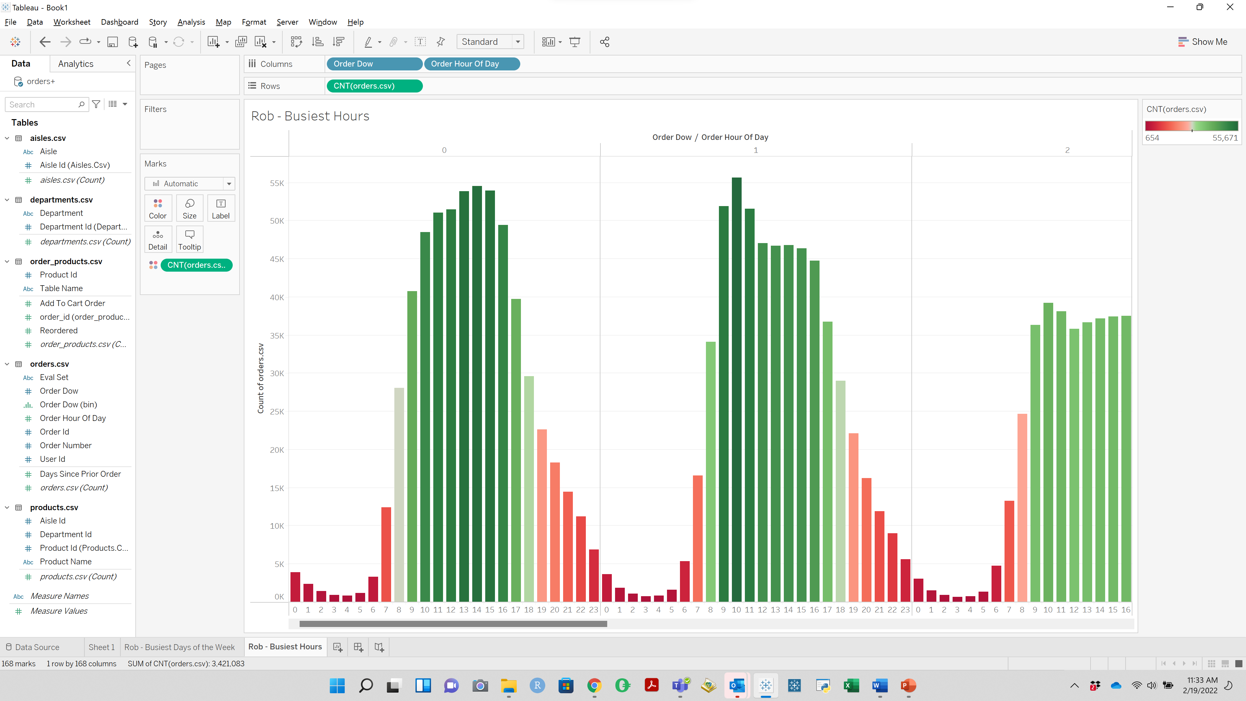

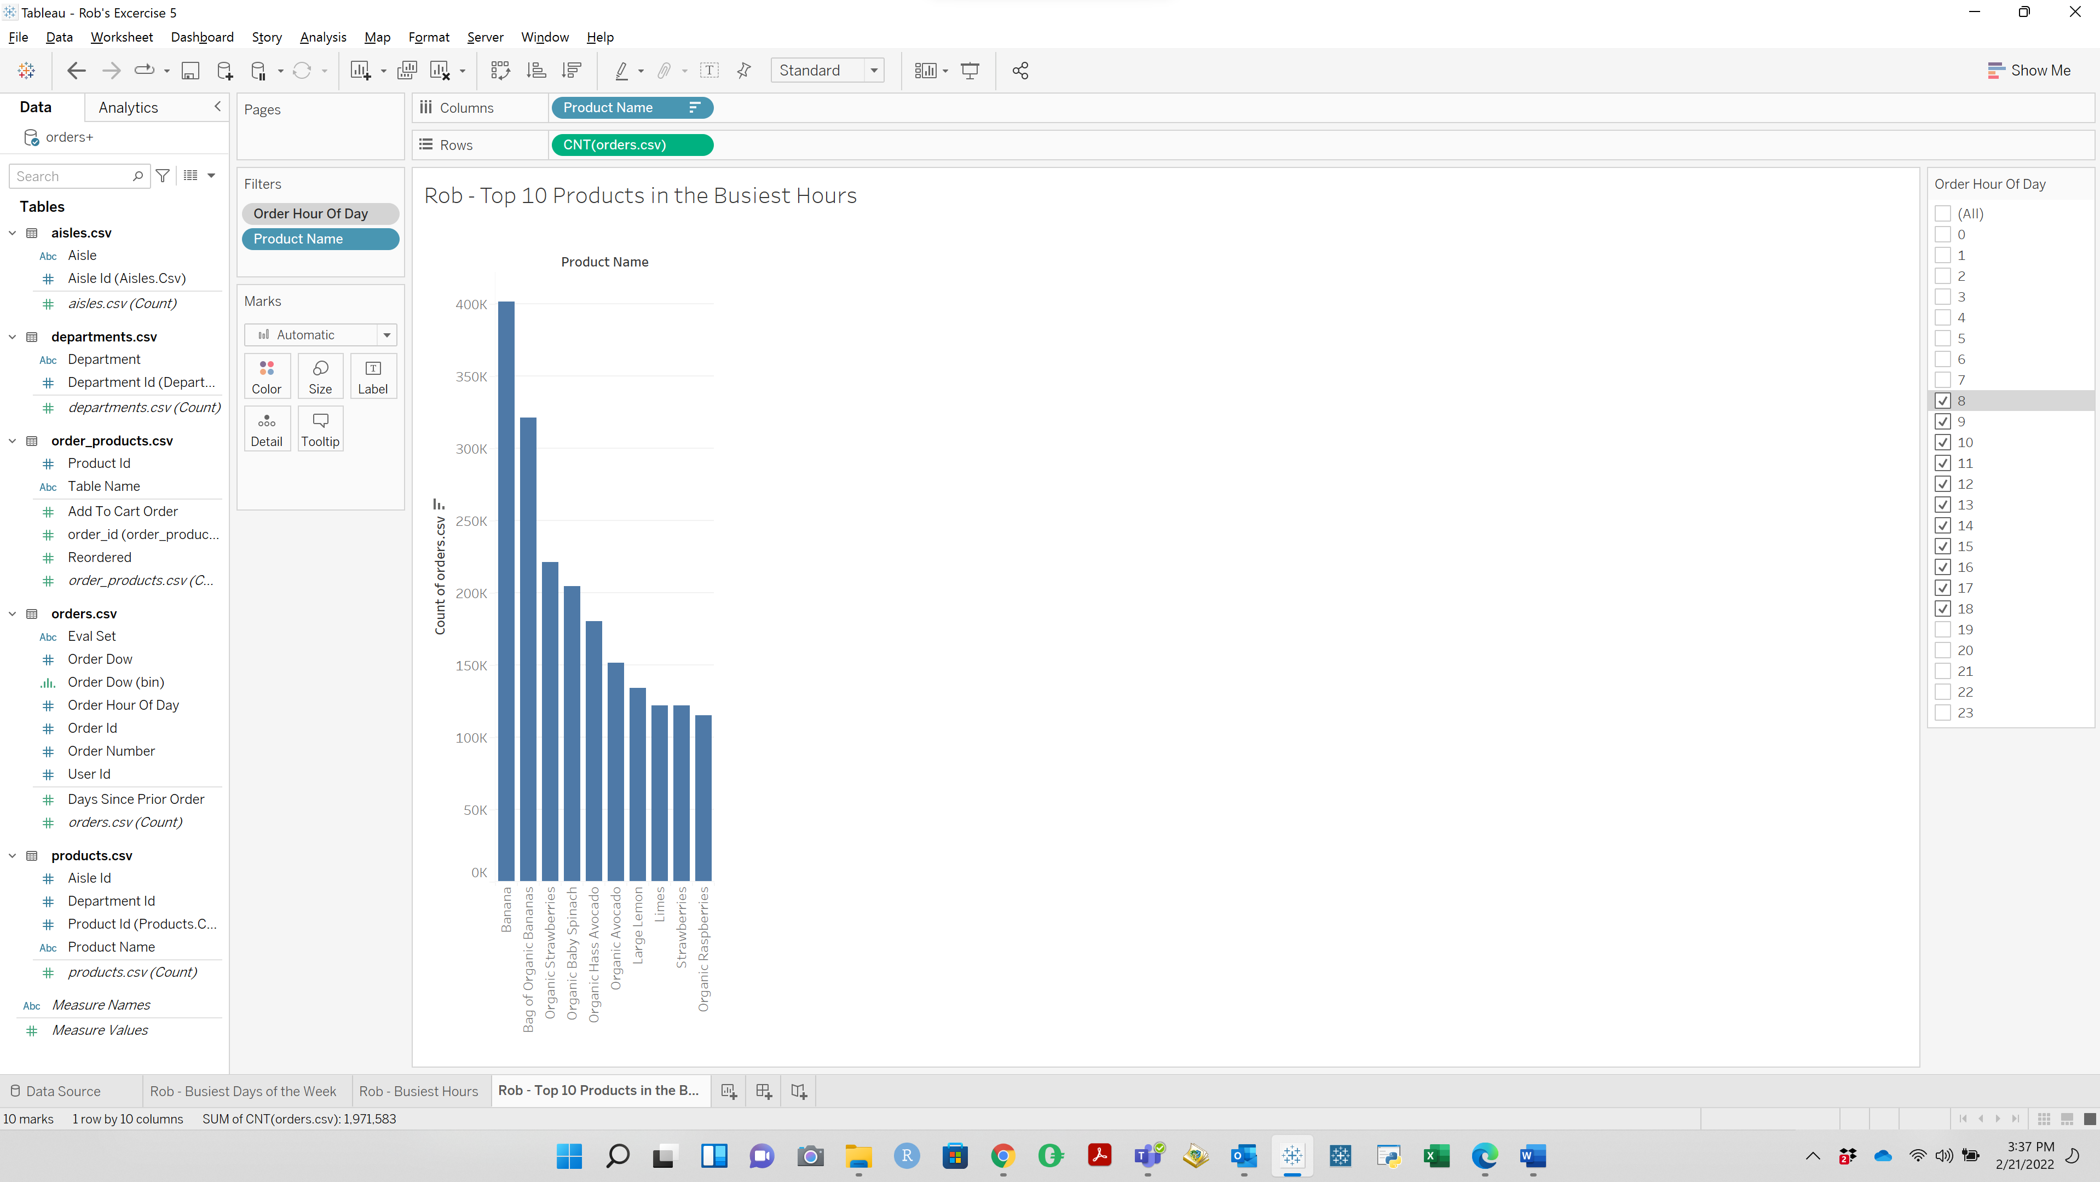

**QUESTION 3**: Top Selling Item During Busiest Hours: Banana

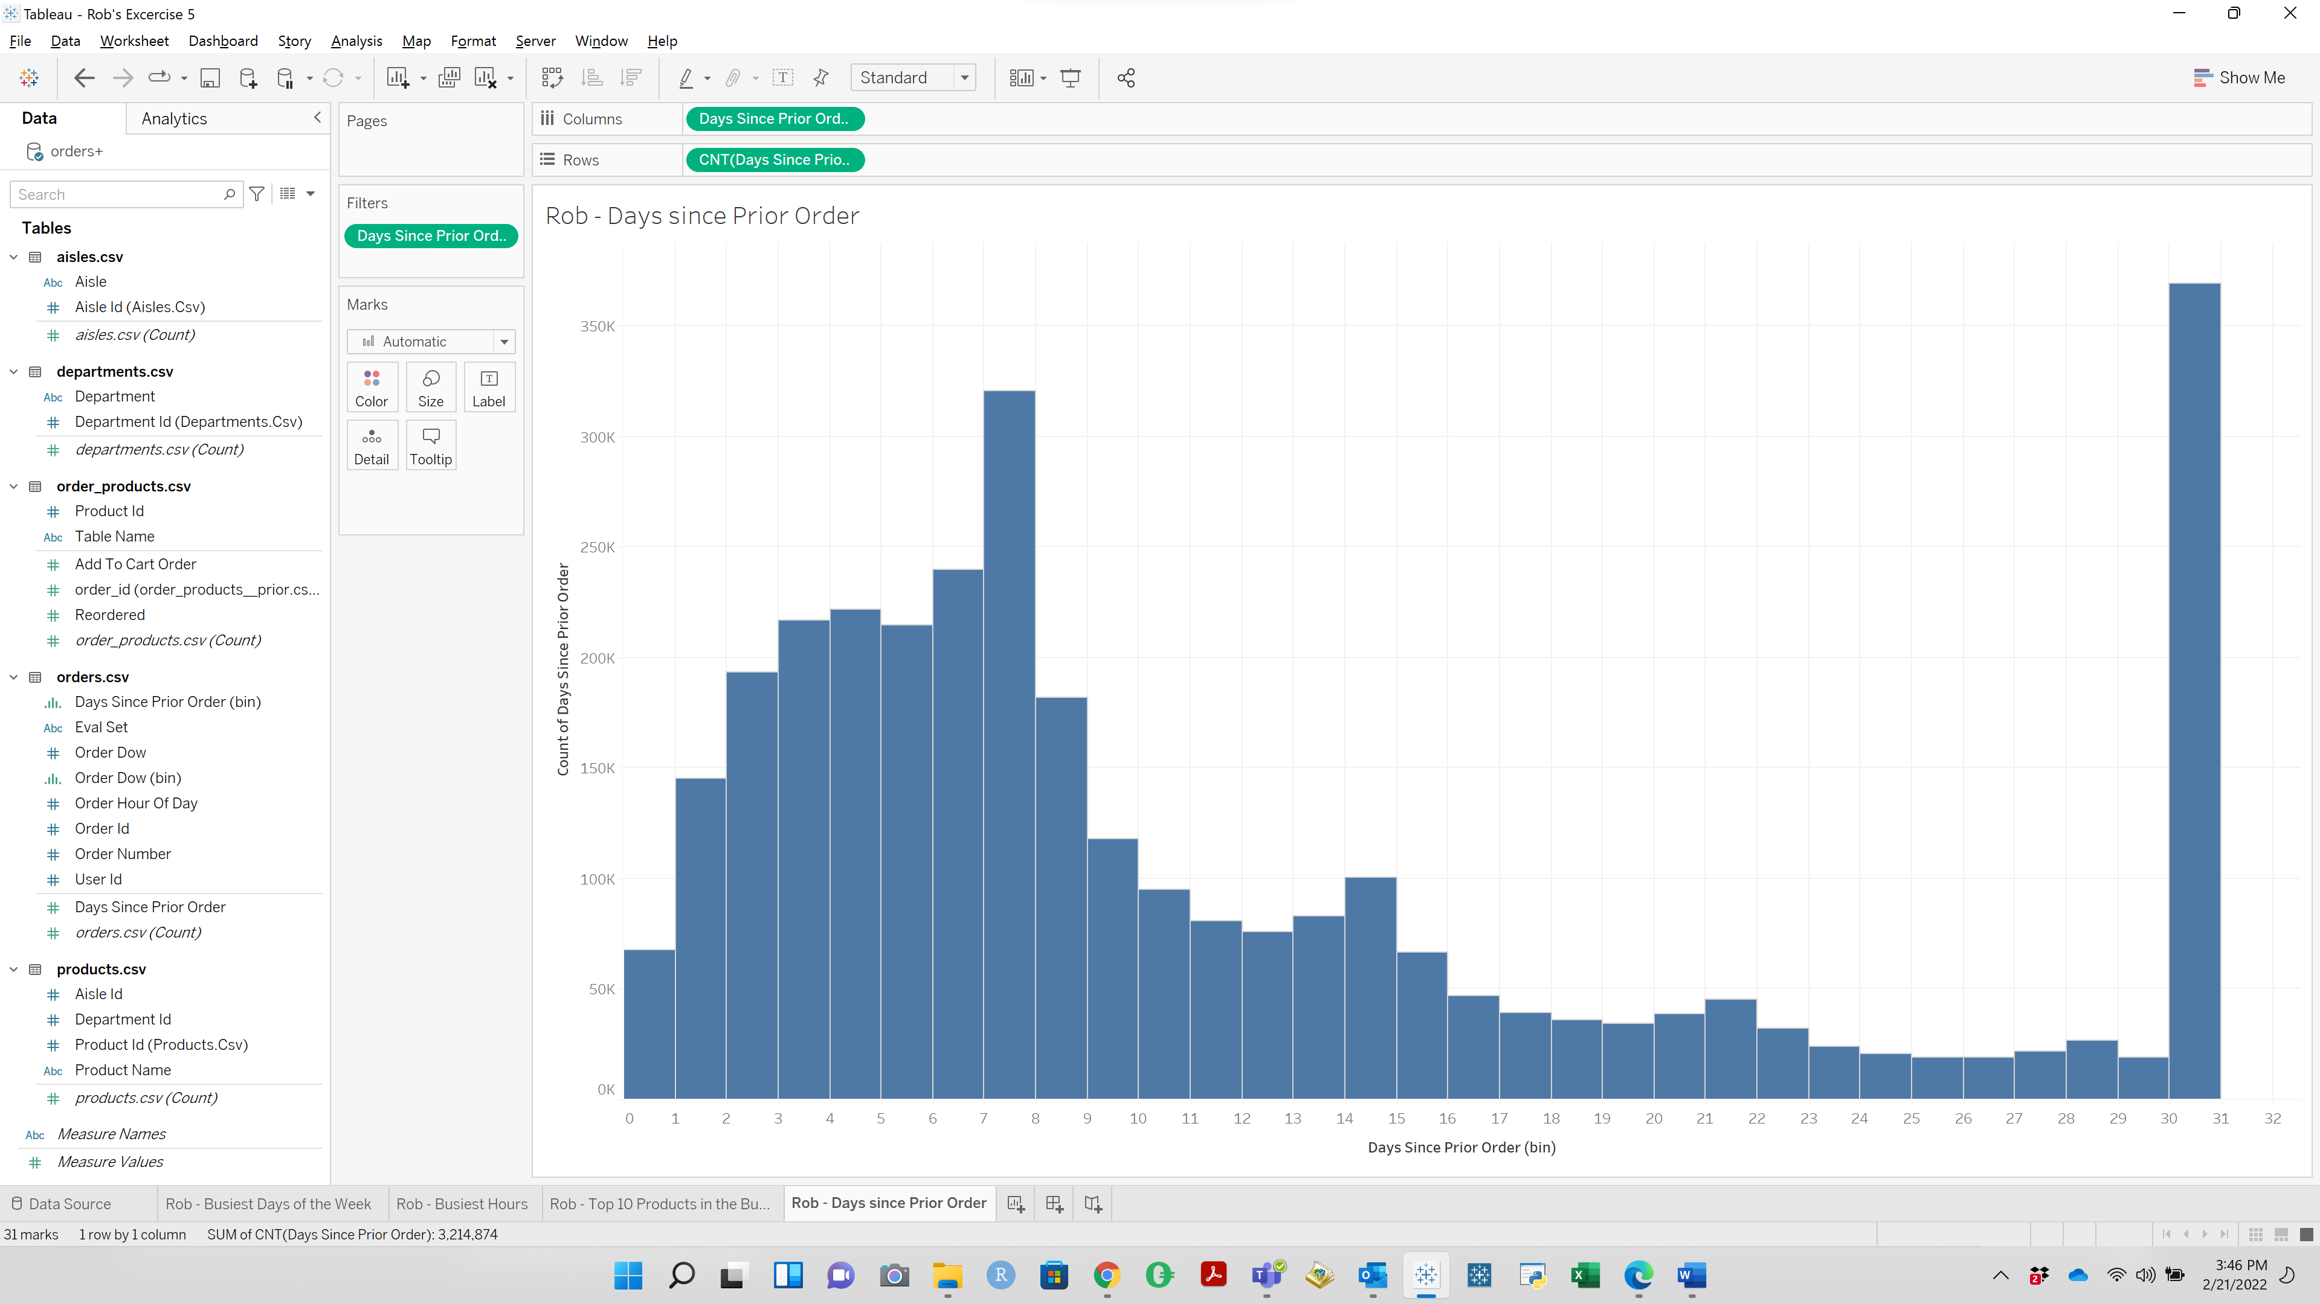

**QUESTION 4**: Customers are most likely to order again on the 30th day after their previous order or 7 days after their previous order

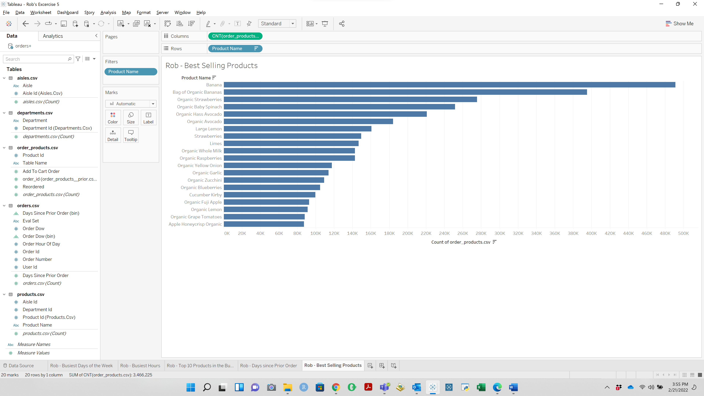

**QUESTION 5**: The top three selling items are Banana, Bag of Organic Banana, Organic Strawberries

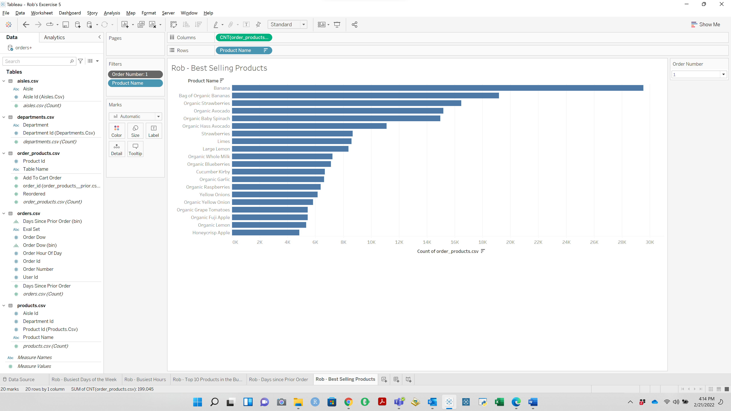

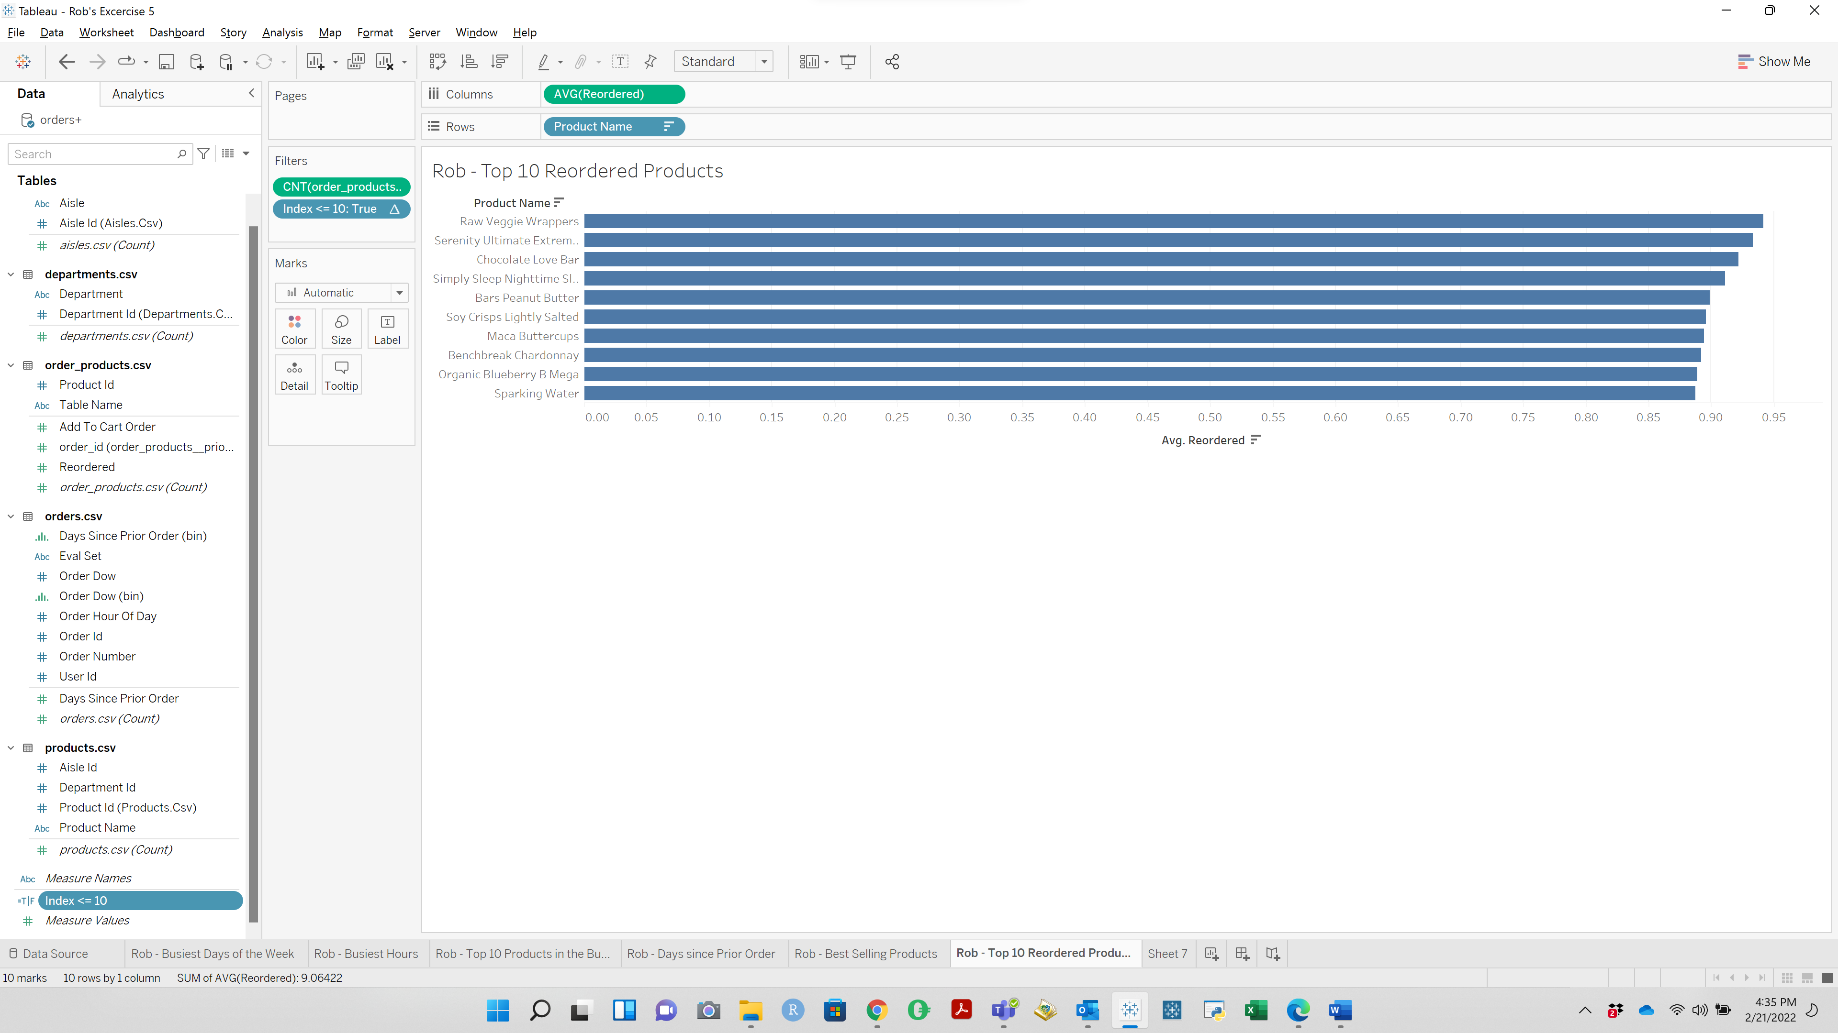

**QUESTION 6**: Raw Veggie Wrappers have a 94.203% chance of being reordered

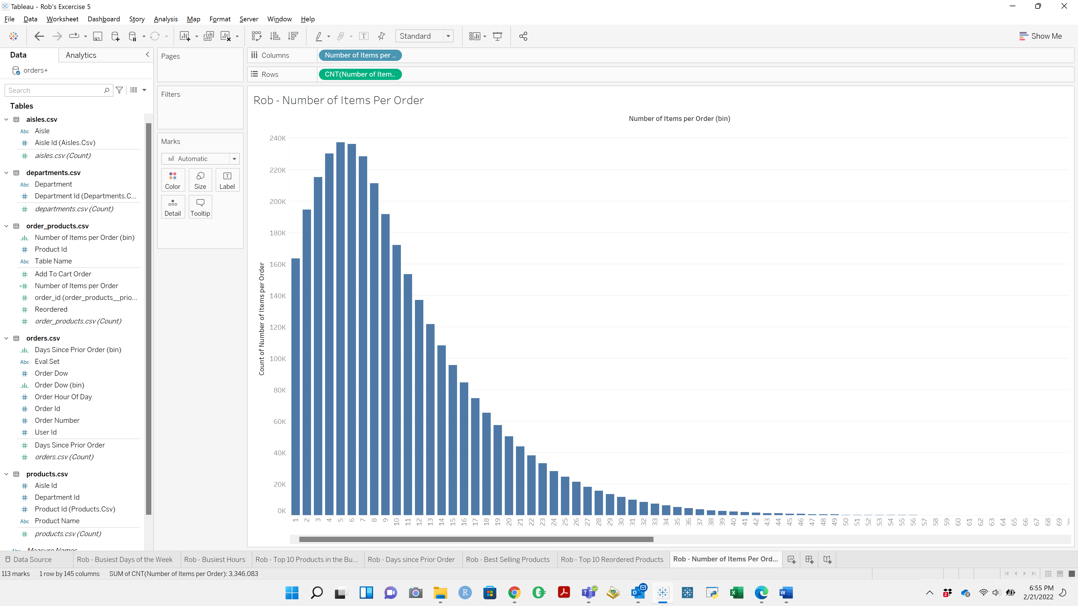

**QUESTION 7**: The most common order amount is 5 items per order

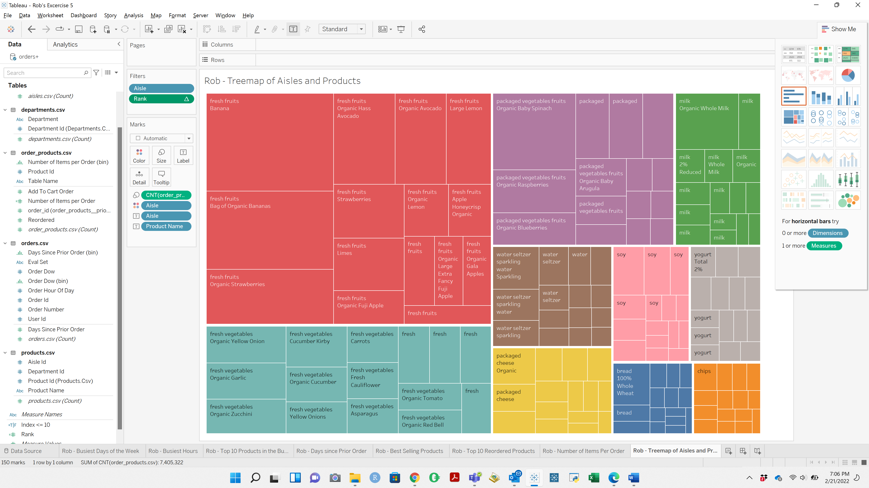

**QUESTION 8**: Fresh Fruits, Fresh Vegetables, Packaged Vegetables Fruits are the three aisles that customers order from the most

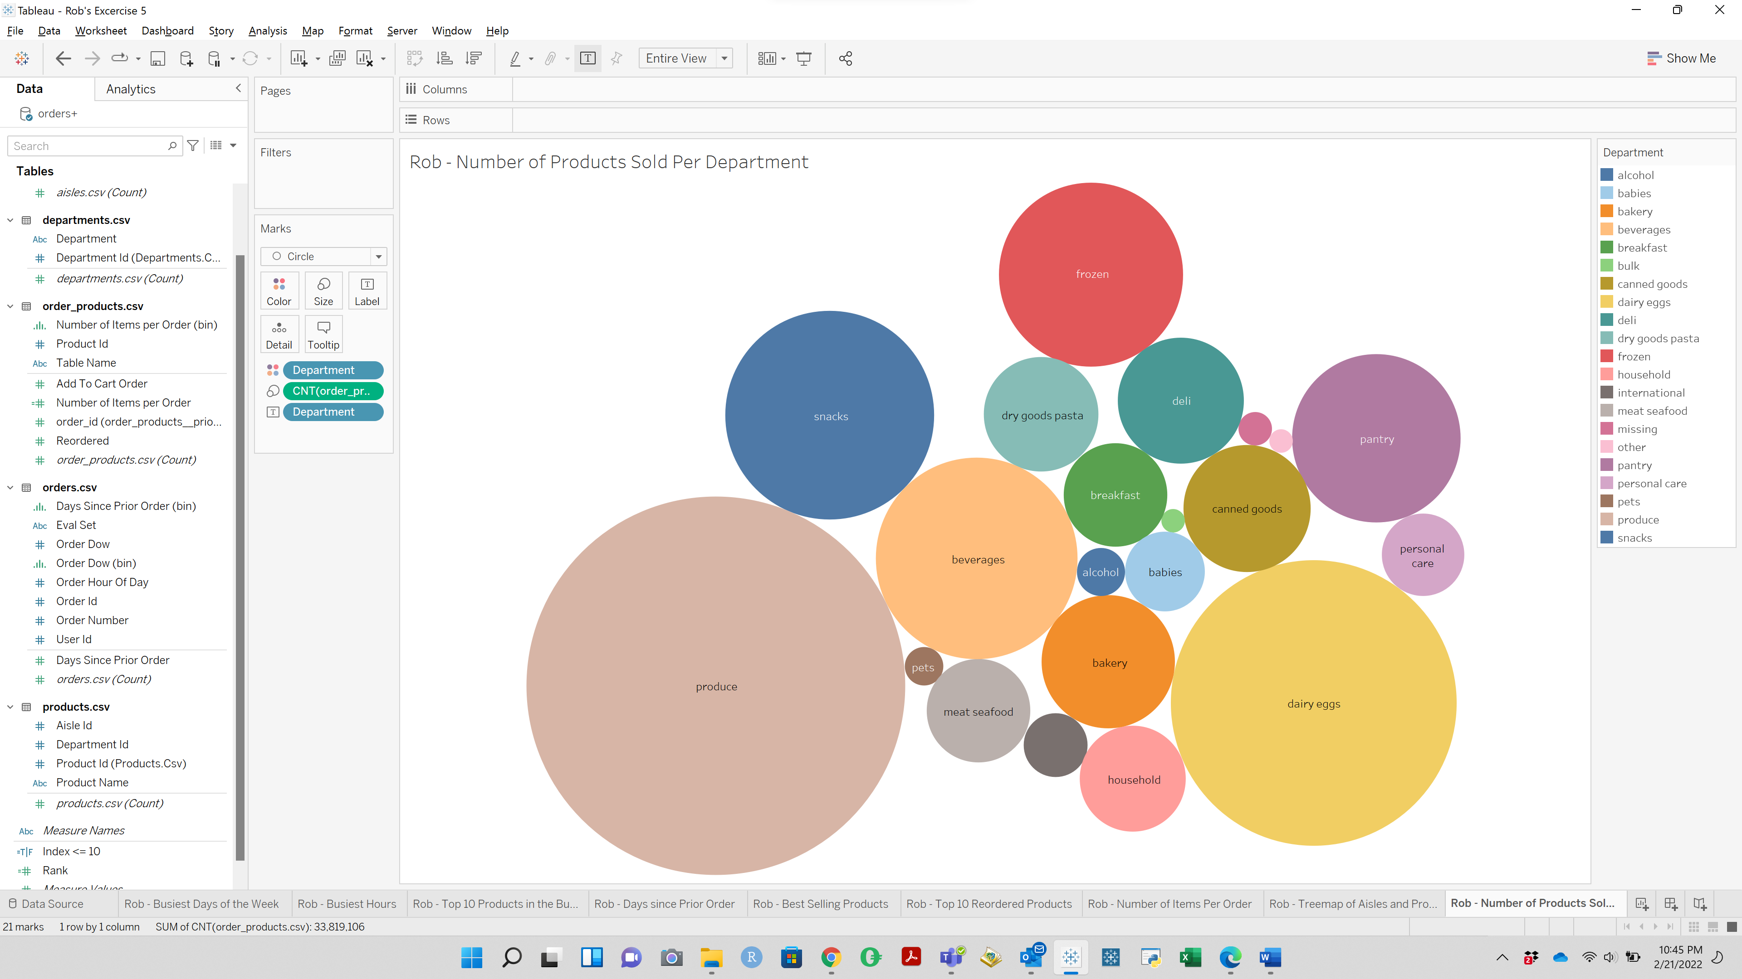

**Question 9**: The top 2 departements are Produce & Dairy Eggs

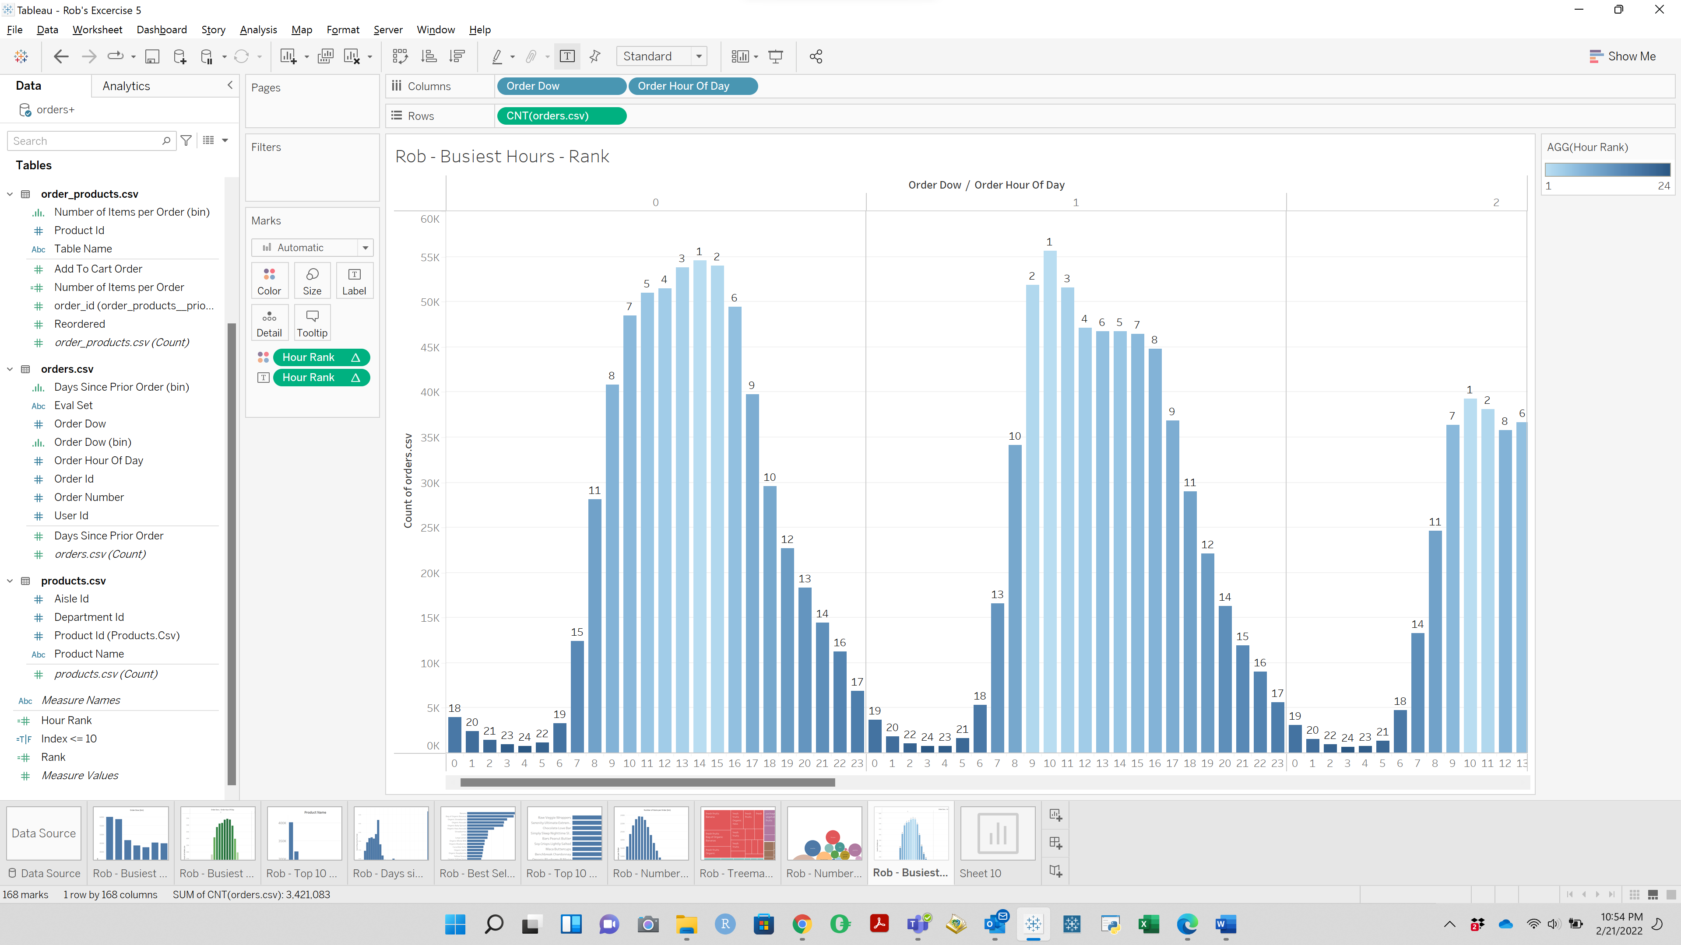

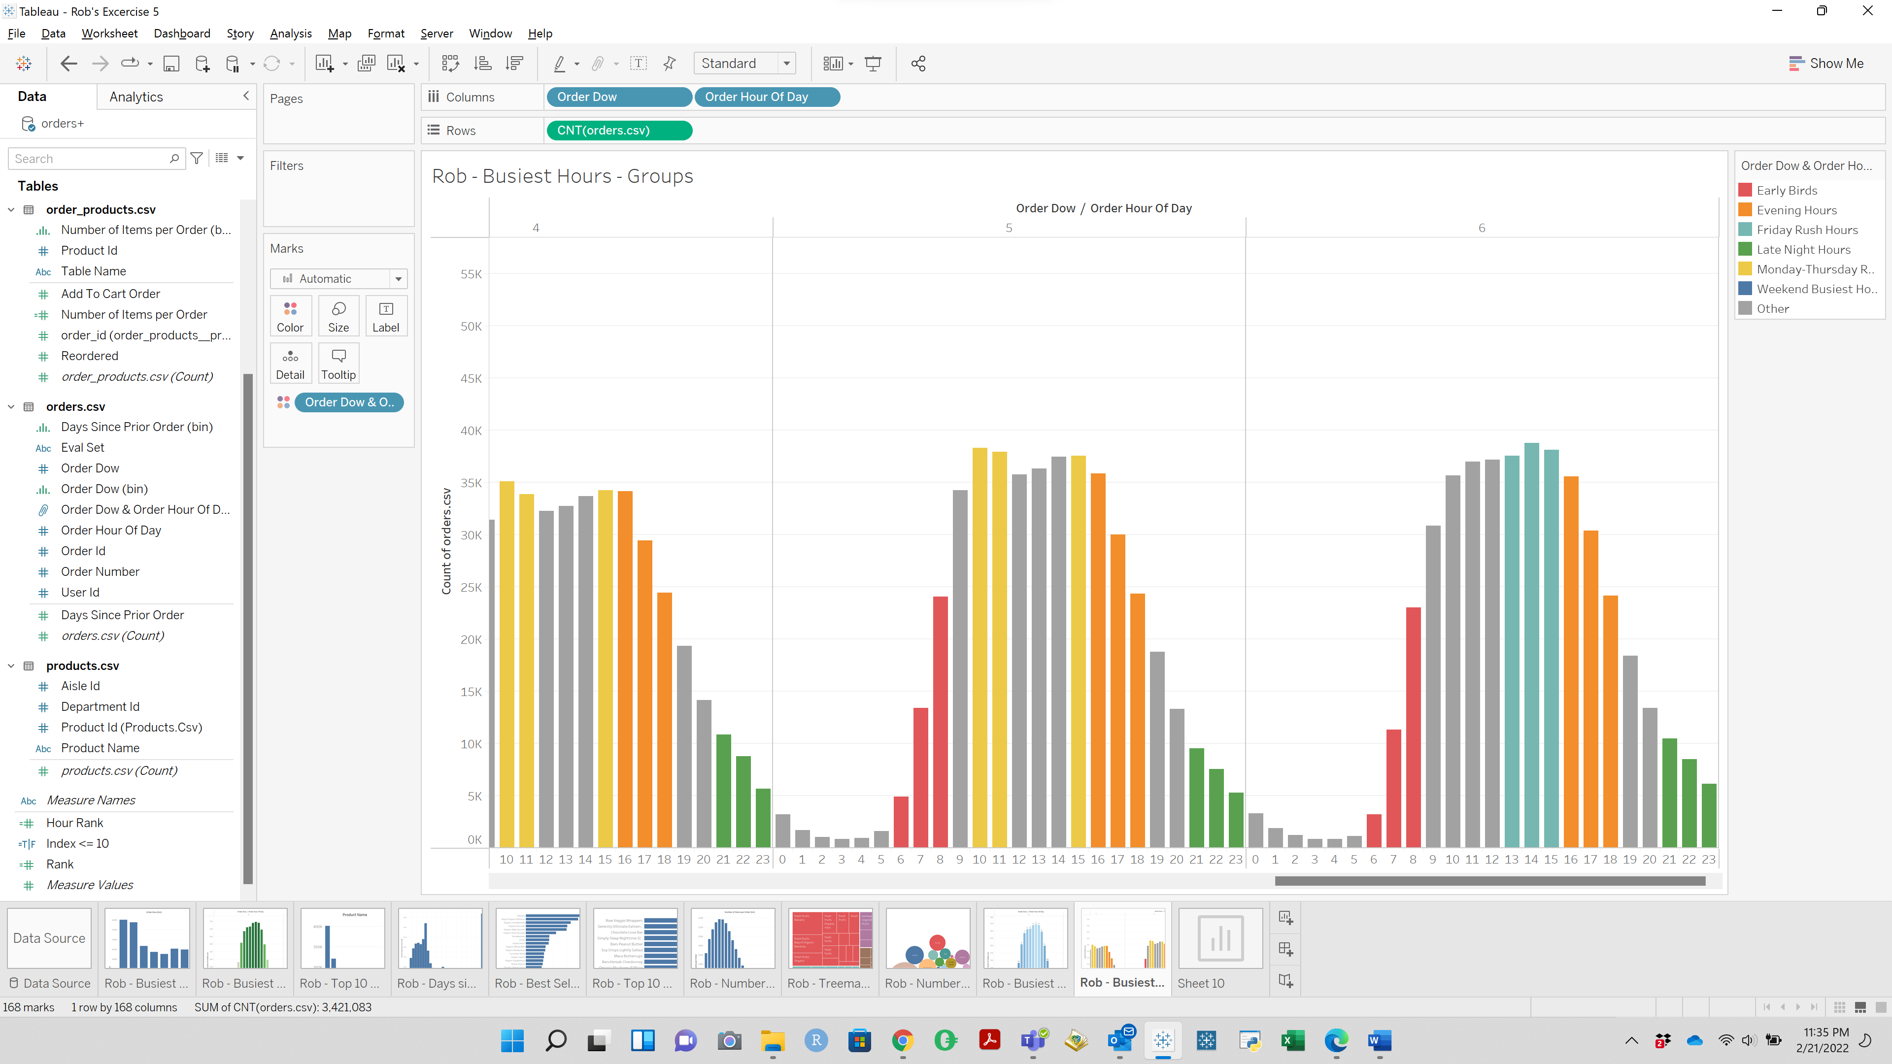

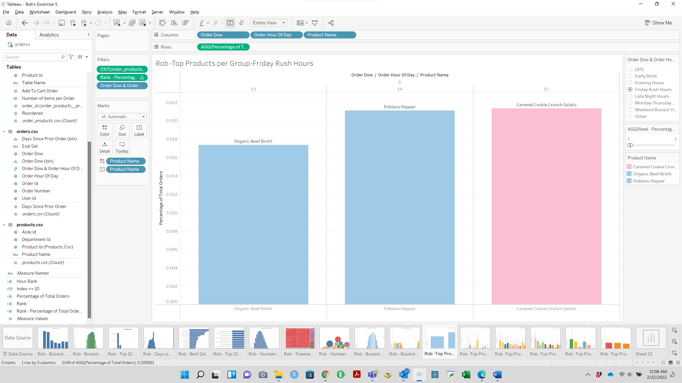

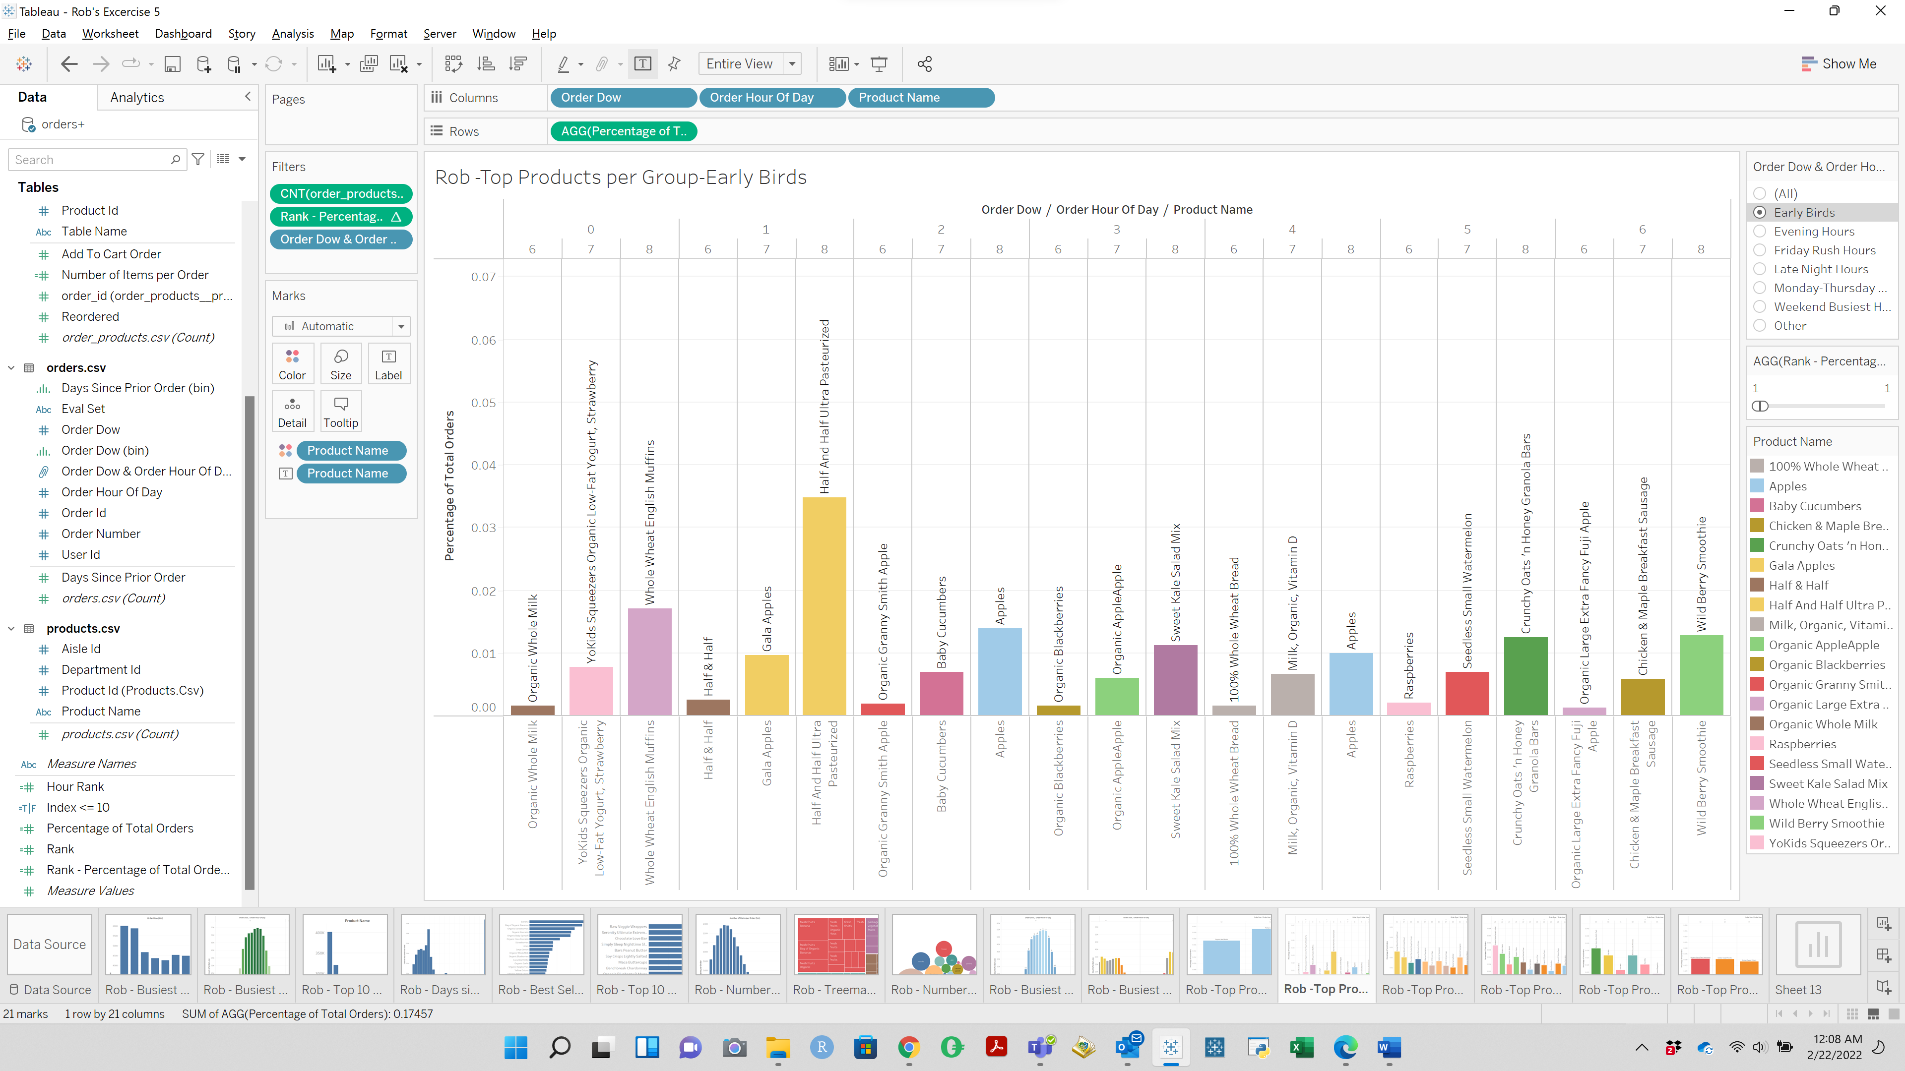

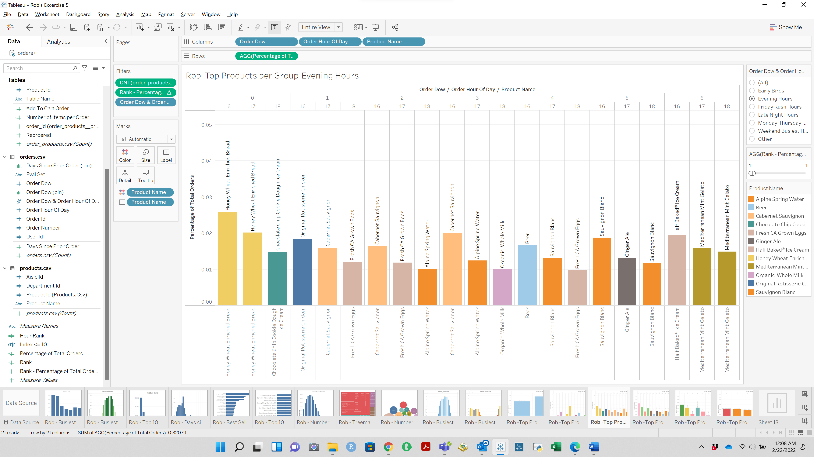

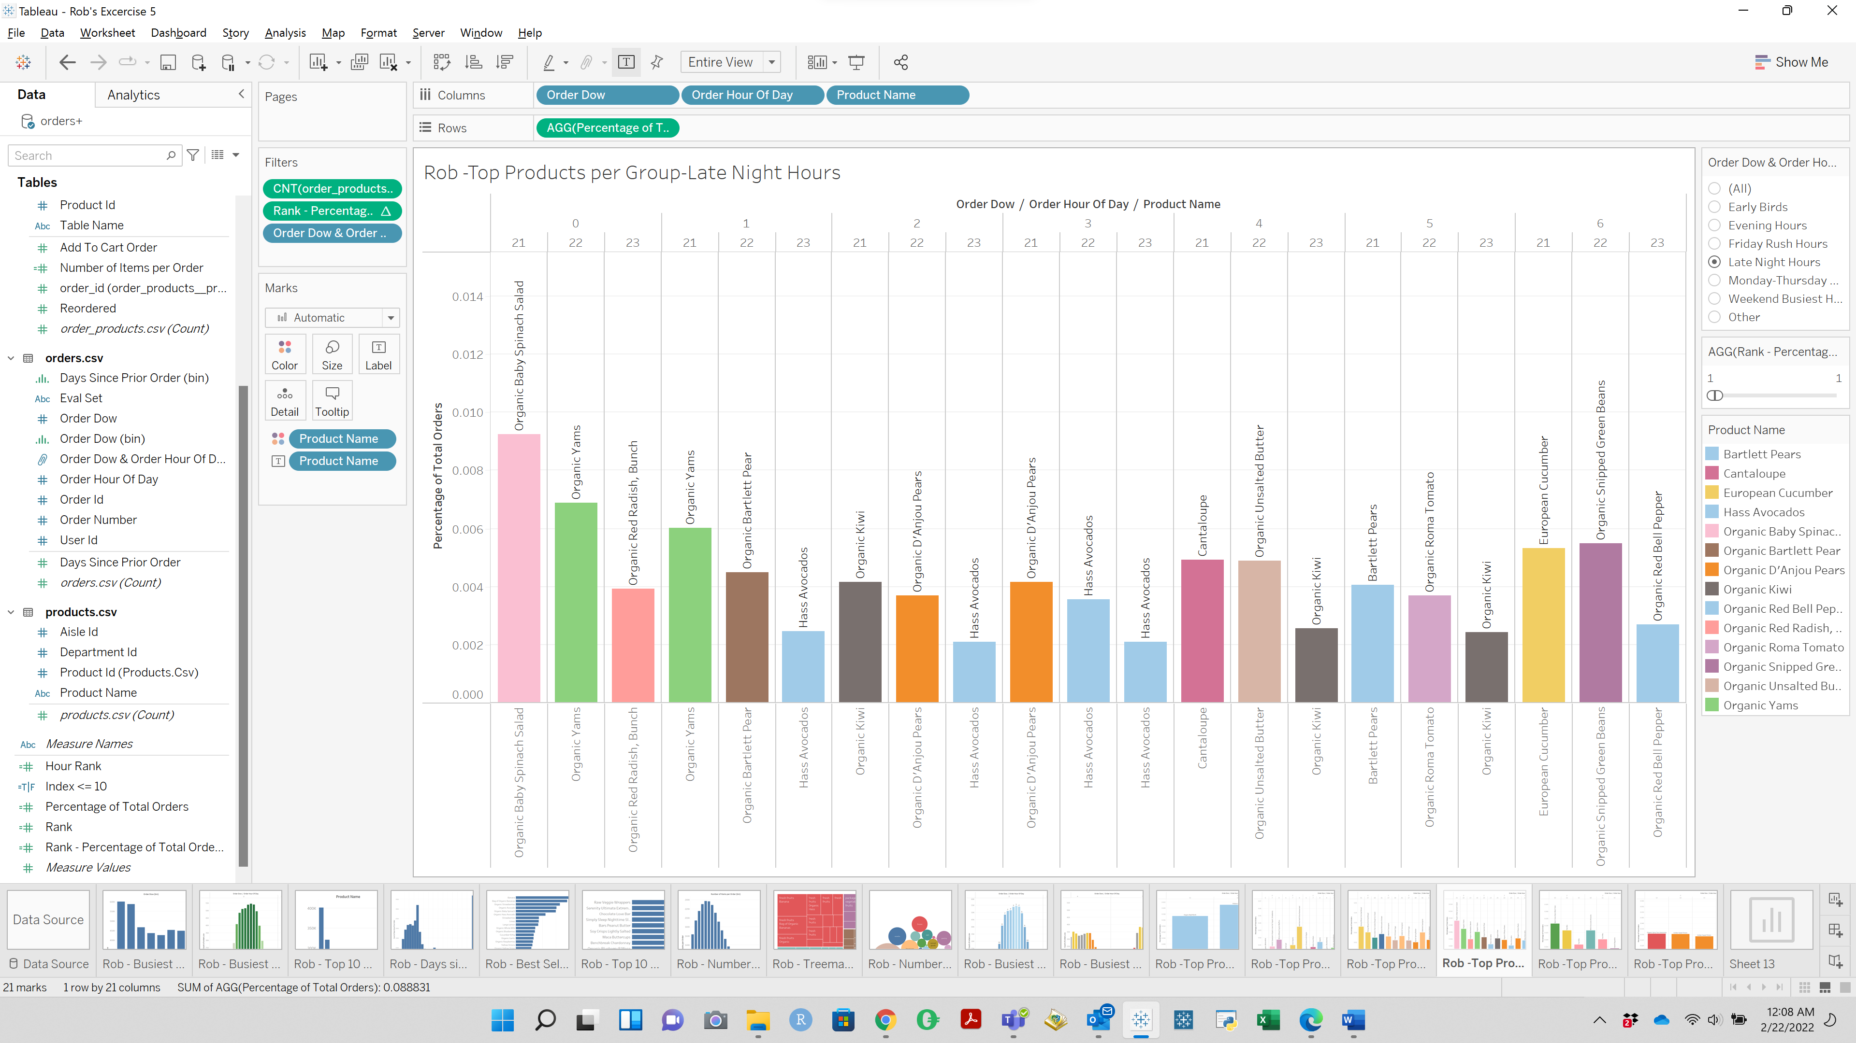

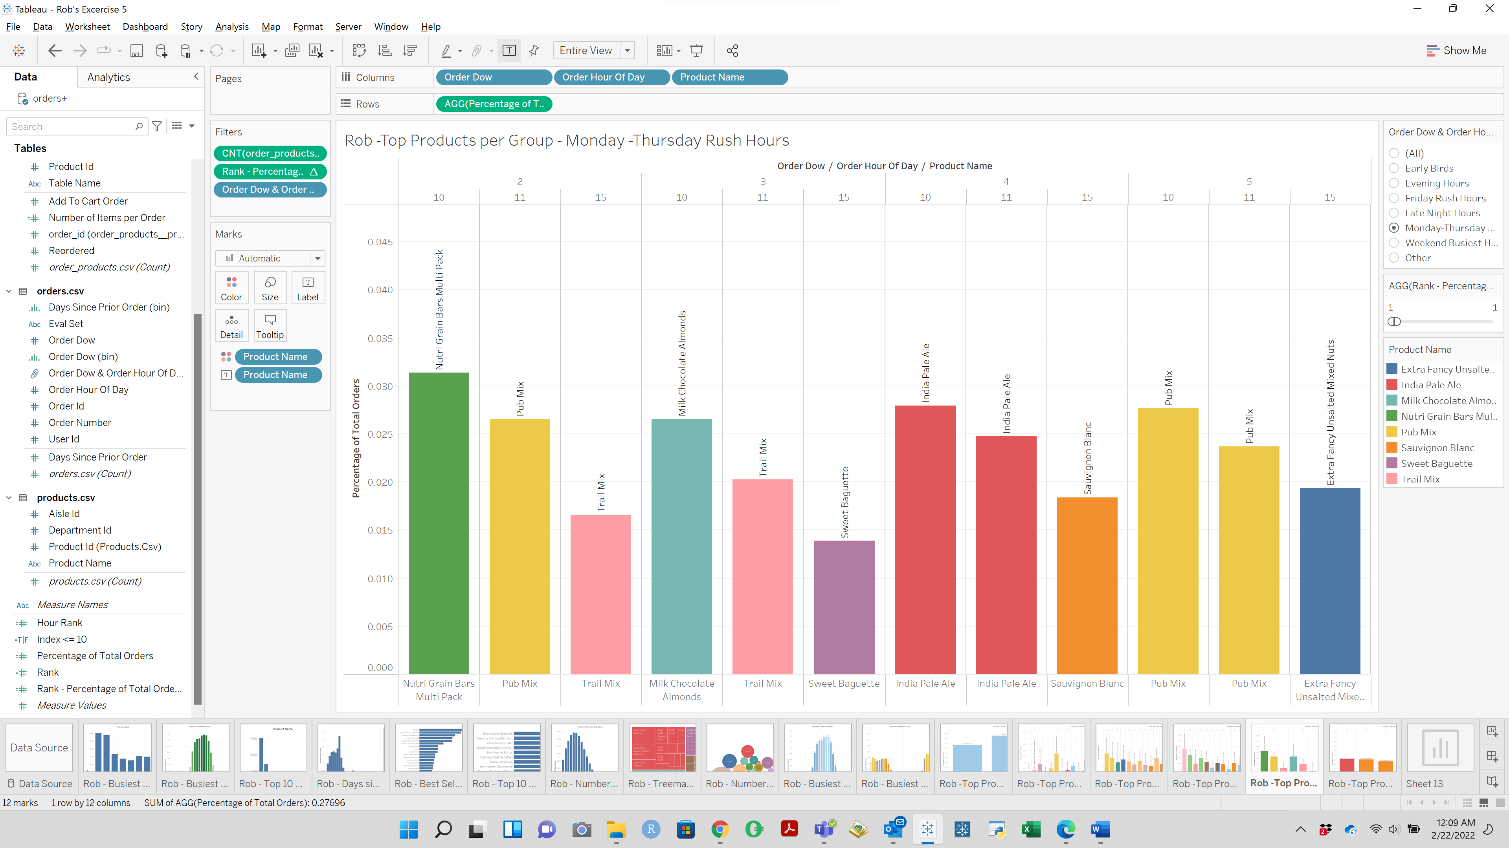

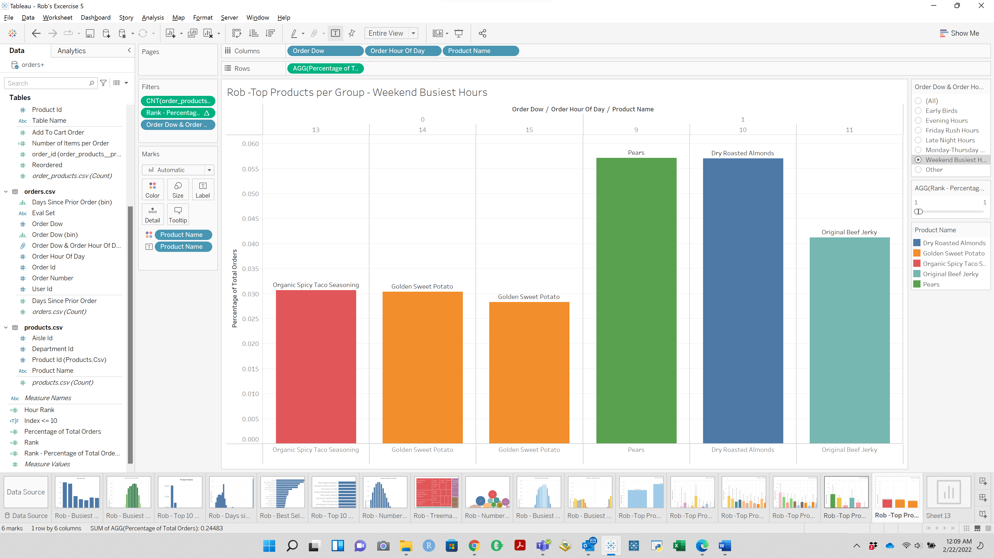

SECTION 5

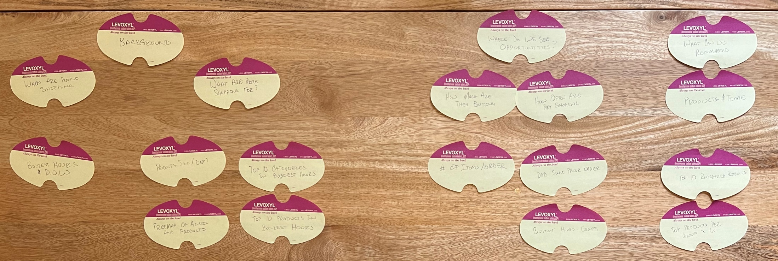

**Freytag’s Pyramid**

1. Busiest Hours & Days of Week – *Beginning*
2. Product Sold Per Department – *Rising Action*
3. Tree Map of Aisles and Products – *Rising Action*
4. Top 10 Categories in Busiest Hours – *Rising Action*
5. Top 10 Products in Busiest Hours – *Rising Action*
6. # of Item Per Order – *Climax*
7. *Days Since Prior Order – Climax*
8. *Busiest Hours –Groups – Climax*
9. *Top 10 Reordered Product – Resolution*
10. *Top Products Per Group x 6 – Resolution*

SECTION 6:

Logical is the best Rhetoric type for this presentation

SCREEN SHOTS OF STORY CAPTION

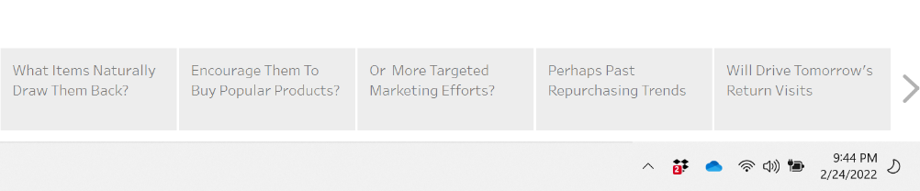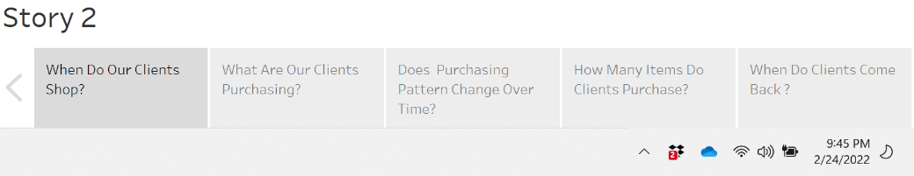

STORY FORMATTING

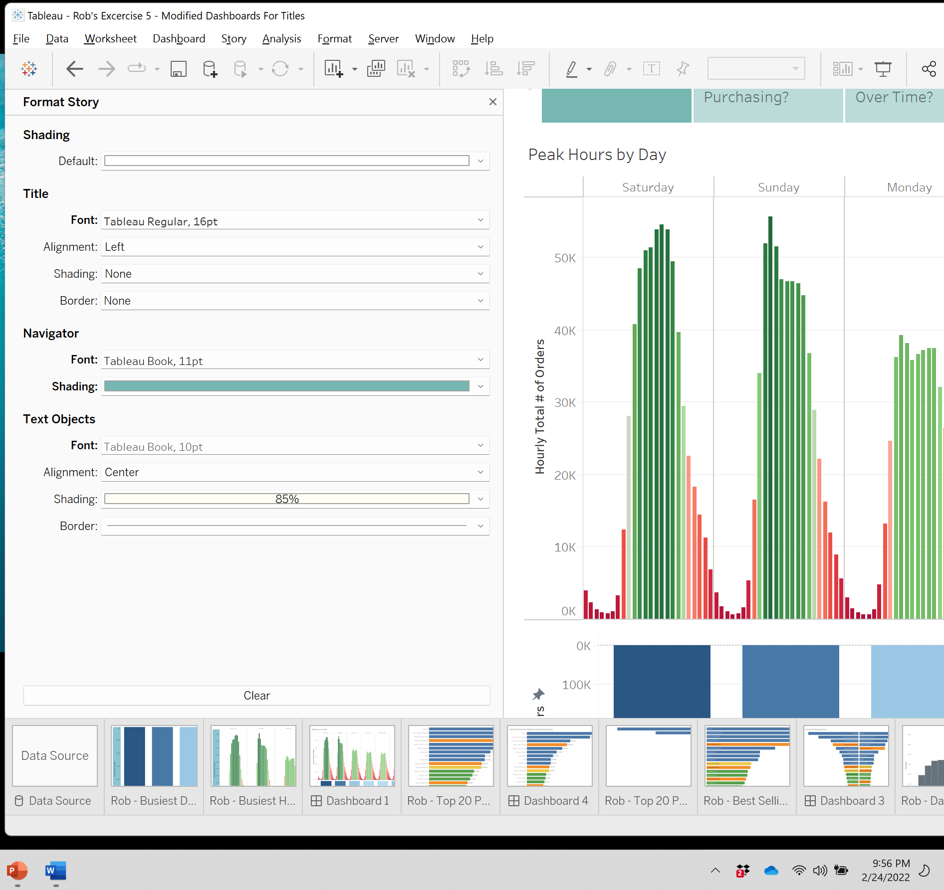

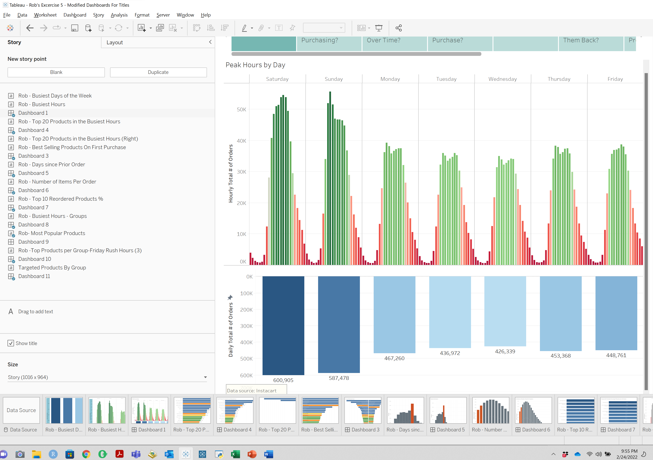

FIRST VIEW OF STORY

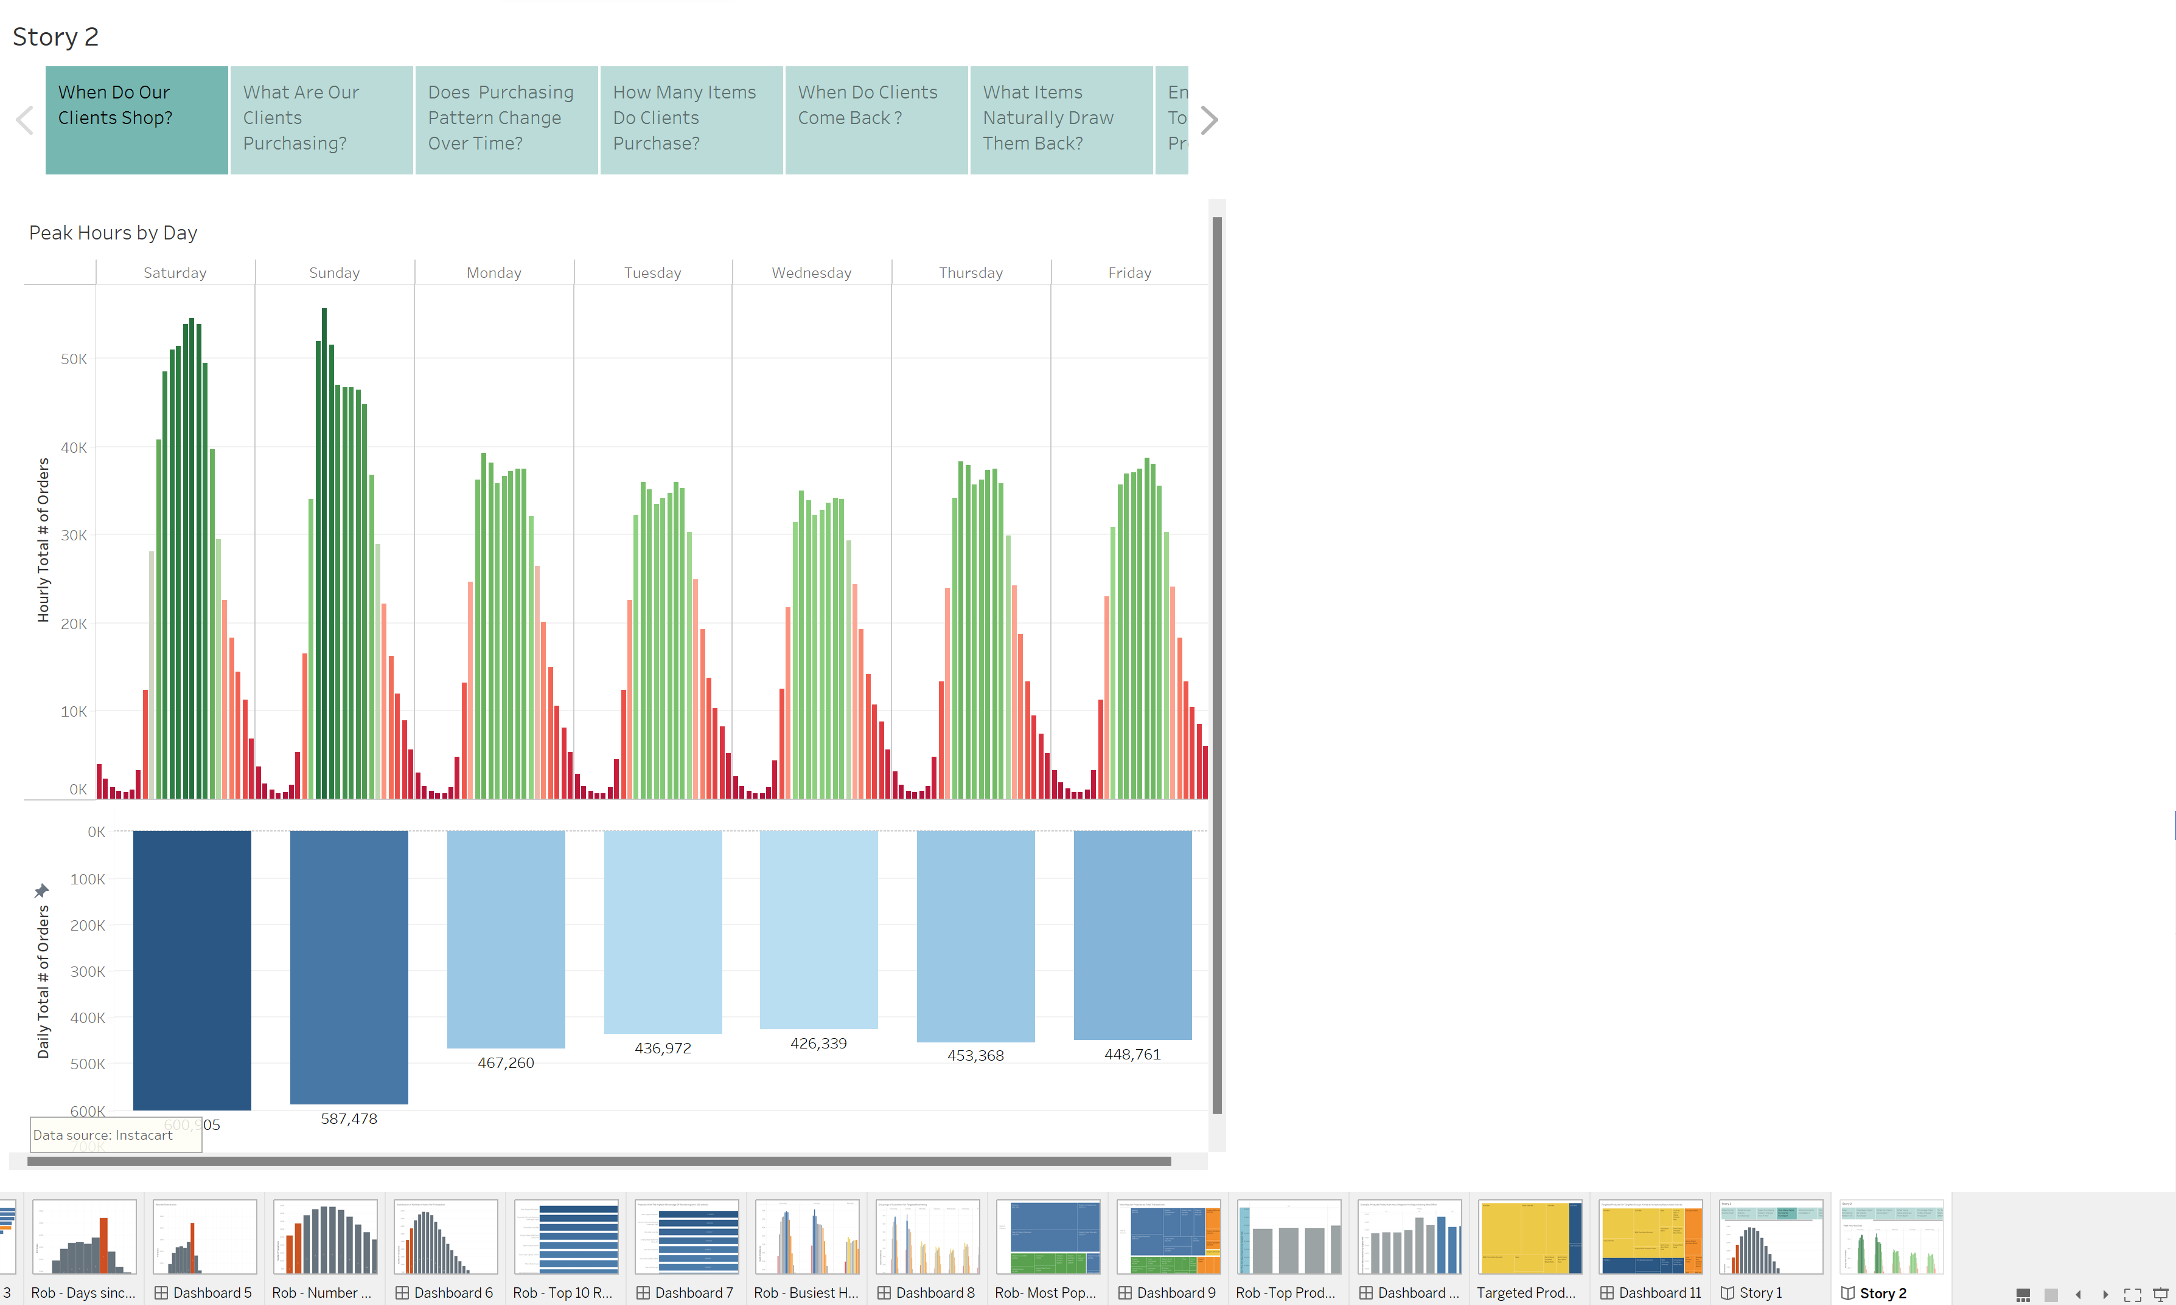

LAST VIEW OF STORY:

